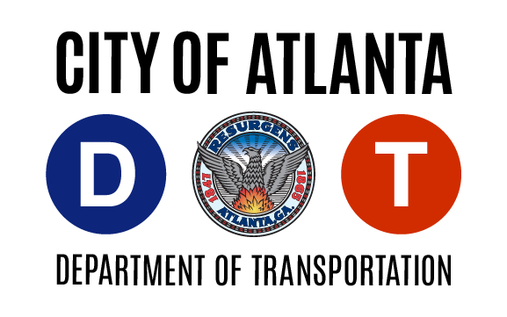
Current Permit # __________________________
Parking Area:

Ansley Park
Ardmore Park
Atkins Park
Brookwood Hills
Buckhead Forest
Dickson Place
Glen Iris
Home Park
Inman Park
Inwood Circle
Midtown
Poncey-Highland
Saunders Street
Summerhill
Vine City
Virginia Highland
55 Trinity Avenue SW, Suite 4350
Atlanta, GA 30303-0354
Telephone: (404) 330.6501
Email: DOT-Permits@atlantaga.gov
GUEST PASS REQUEST

- Applicant's Name __________________________________________________________
(Last) (First) (Middle Initial)

2. Applicant's Address _________________________________________________________
(Number) (Street) (Unit) (Zip Code)

3. Telephone Number _____________________

4. Applicant's Driver's License Number

State of Issuance __________________________

5. Make of Vehicle _________________________

6. Body Style ______________________________ Year ______________________________

7. License Tag Number ____________________

8. Proof of Residency Provided ________________________________________________

________________________________________________ _____________________________

Applicant’s Signature Date

________________________________________________________________________________________________

INSTRUCTIONS

Please complete the application and return via email or US mail. Copy of Current Driver’s License and Proof of Residency is required. Current permit holders do not have to resubmit required documents only the permit number.

